Connect to RPI via “Raspberry Connect”

- Open a web browser and type “https://connect.raspberrypi.com/sign-in”. Type in the e-mail and password given to you through WhatsApp.
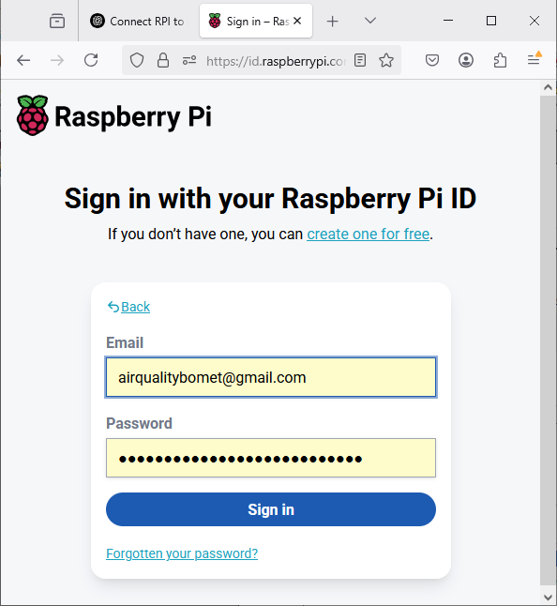
- In case you receive an error message, type "https://connect.raspberrypi.com/devices" into your address bar. You should then see this:
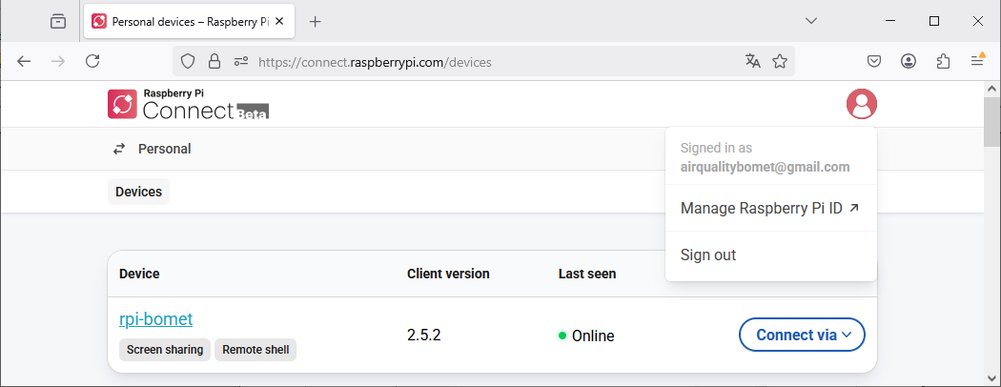
3. The "Last seen" should show a green bullet and "Online". If so, SUCCESS!! You can now connect using Remote shell or Screen sharing. NB:Screen sharing gives you a nice window interface, but it needs a much stronger internet connection. Try it out and see if it works.

